Blockchain Platforms with ORM Stack

Contents

1. Introduction 3
2. Workflow diagram to deploy the stack 3
3. Create stack for Blockchain 4
4. Plan the Job 6

Introduction

Oracle Blockchain Platform gives a pre-assembled platform for building and running smart contracts and maintaining a tamper-proof distributed ledger. It is a fully managed service that simplifies the process of developing and deploying blockchain solutions.

Workflow diagram to deploy the stack

Below diagram shows how the Terraform Artifact are applied in the OCI. While creating a ORM stack, using terraform deliverables Init, Plan and Apply is the flow to provision the resource in the OCI. We can have the deliverables in any of below.

- GitLab/GitHub Repo
- Bitbucket
- Can be in folder/.zip in the local disk
- Object Storage Bucket
- Can be in compartment
- Oracle provided Template



Prerequisite:
- Create IDCS access token
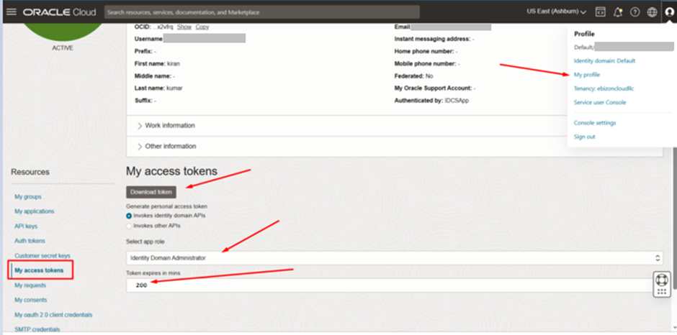

Create stack for Blockchain

Go to OCI Console Developer Services Resource Manager Stacks select the compartment Create Stack

My Configuration Folder Browse Select the “Blockchain” folder that contains the terraform Upload

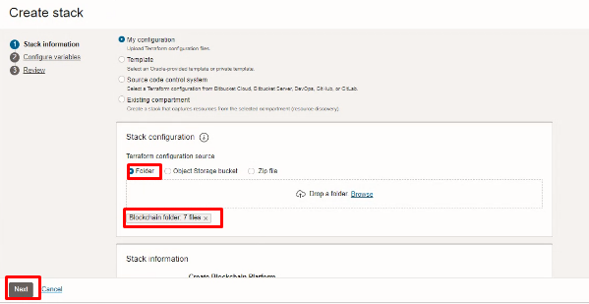

Select the parameters as per the below screen,

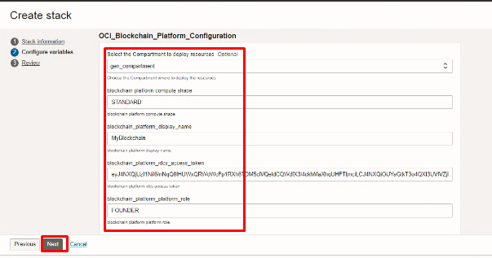
Click “NEXT”

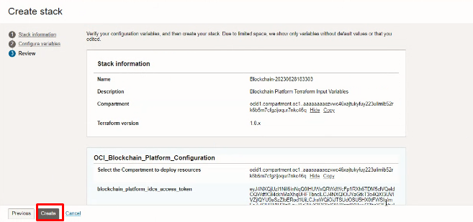
Click “CREATE”

Plan the Job

Click the “Plan”
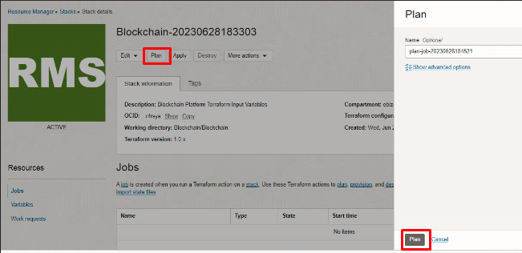

Verify the Plan is successful.
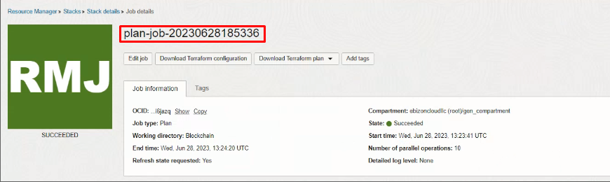

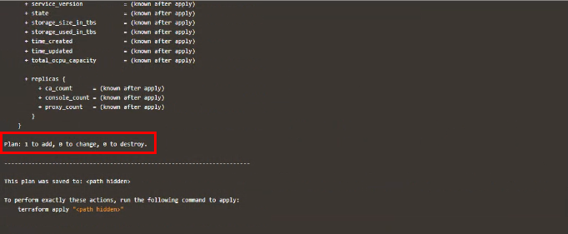

#END#

